
Design Analysis of Algorithms
ENCA351

Lab Assignment -2

K. R. MANGALAM UNIVERSITY, GURUGRAM, HARYANA, INDIA

Submitted to: - Submitted By: -
Dr. Aarti Sangwan Varun Sain
2301201134

Problem 1: Scheduling TV Commercials to Maximize Impact (Greedy Job Sequencing)
Solution
  - Sort commercials by profit and assign each to the latest free slot before its deadline.
  - Greedy choice ensures the most profitable feasible set under slot constraints.
  - Use a slot array to avoid overlaps and compute total revenue.

Time Complexity:
  - Time: O(n log n + n · d) where d is the max deadline
  - Space: O(d)

Code Section:
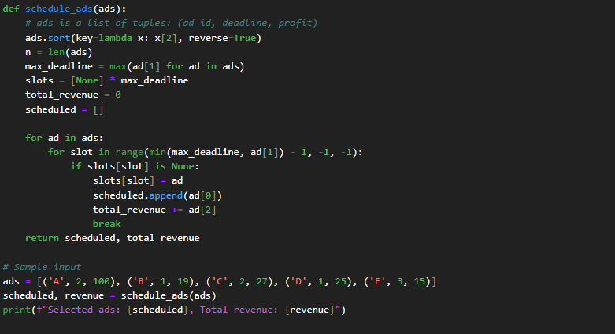

Output:

Graph(s):
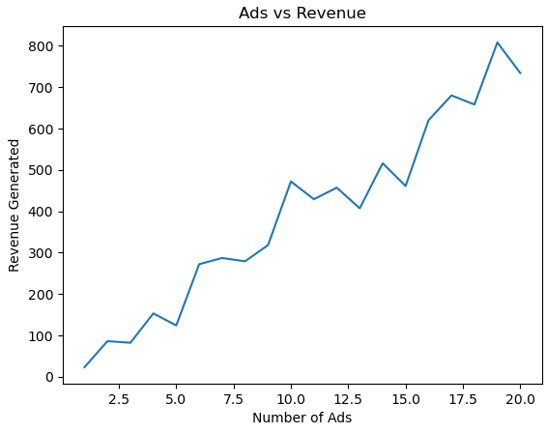

Problem 2: Maximizing Profit with Limited Budget (0/1 Knapsack, DP)
Solution:
  - Bottom-up DP where each state stores best value with capacity constraint.
  - Transition compares pick vs skip of current item.
  - Answer is dp[n][capacity].

Time Complexity:
  - Time: O(n · C)
  - Space: O(n · C) or O(C) optimized

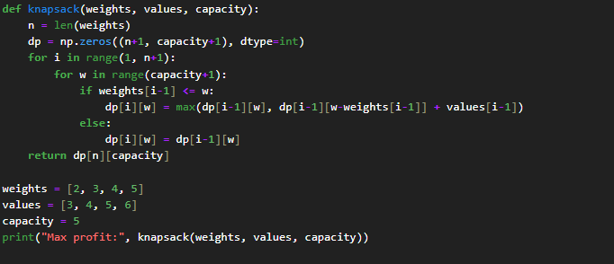
Code Section:

Output:


Graph(s):
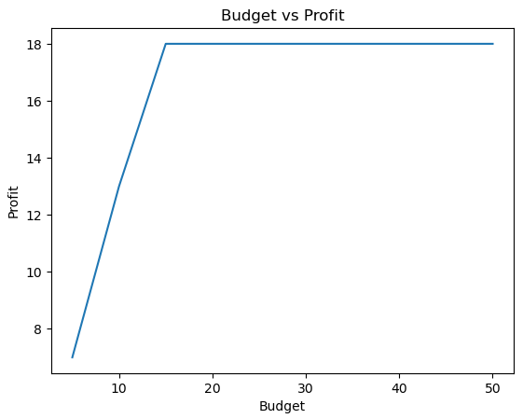

Problem 3: Solving Sudoku Puzzle (Backtracking)
Solution:
  - Fill empty cells by trying digits 1–9 that satisfy row/column/box constraints.
  - Backtrack on conflicts until a valid completion is found.
  - Prints the solved grid if it exists.

Time Complexity:
  - Time: Exponential worst case (pruned by constraints)
  - Space: O(1) extra; recursion stack up to O(81)

Code Section:
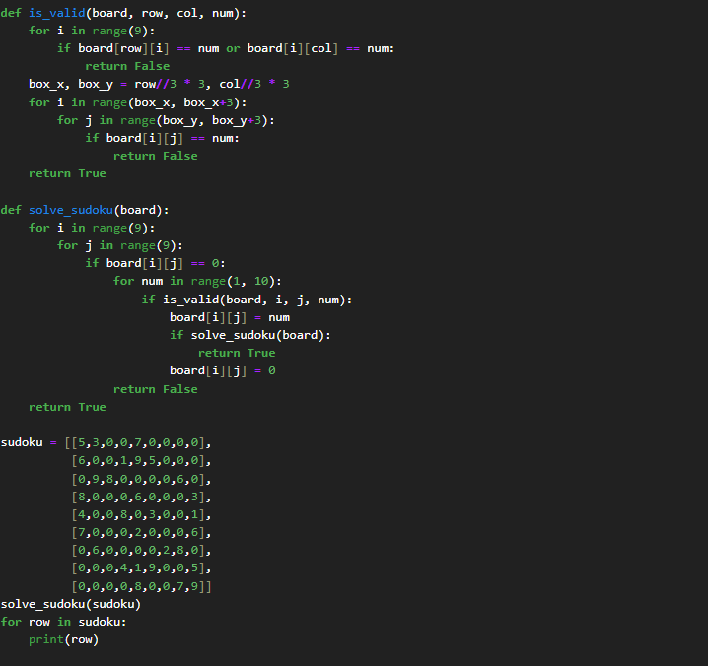

Output:
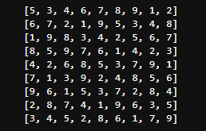

Problem 4: Password Cracking Naive (Brute-Force)
Solution:
    - Generate all strings from the charset up to the target length; stop on a match.
    - Demonstrates exponential scaling with length/charset size.
    - Optional timing visualization to show growth.
Time Complexity:
    - Time: O(k^L)
    - Space: O(L)

Code Section:
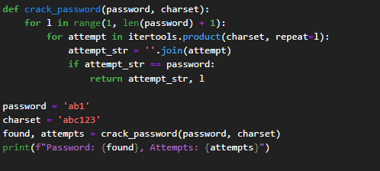

Output:


Graph(s):
